Event Response Table
Event: Employee applies for membership
Event | Source | Trigger | Activity | Response | Destination
Employee login website | Employee | Employee username and password | Find employee record and verify password.  Send Welcome Web Page | Welcome Web page | Employee
Employee do a member application | Employee | Application details | List the application requirement | Employee information | Admin
Application submission | Employee | Application details | Send the application.  Display the submission | Submitted application | Admin
Eligibility check | Admin | Application details | Verify the application eligibility | Information checking | Admin
Approval/denial decision | Admin | Click “Approve” or “Reject” button | Display the employee application.  Store data on Member Record | Decision approval | Admin
Send employee email | Admin | Temporal | Send employee an email application decision | Notification sent to the employee | Employee
Membership Fee | Employee | Deduct from salary or pay away | Display the fee | Fee displayed | Employee

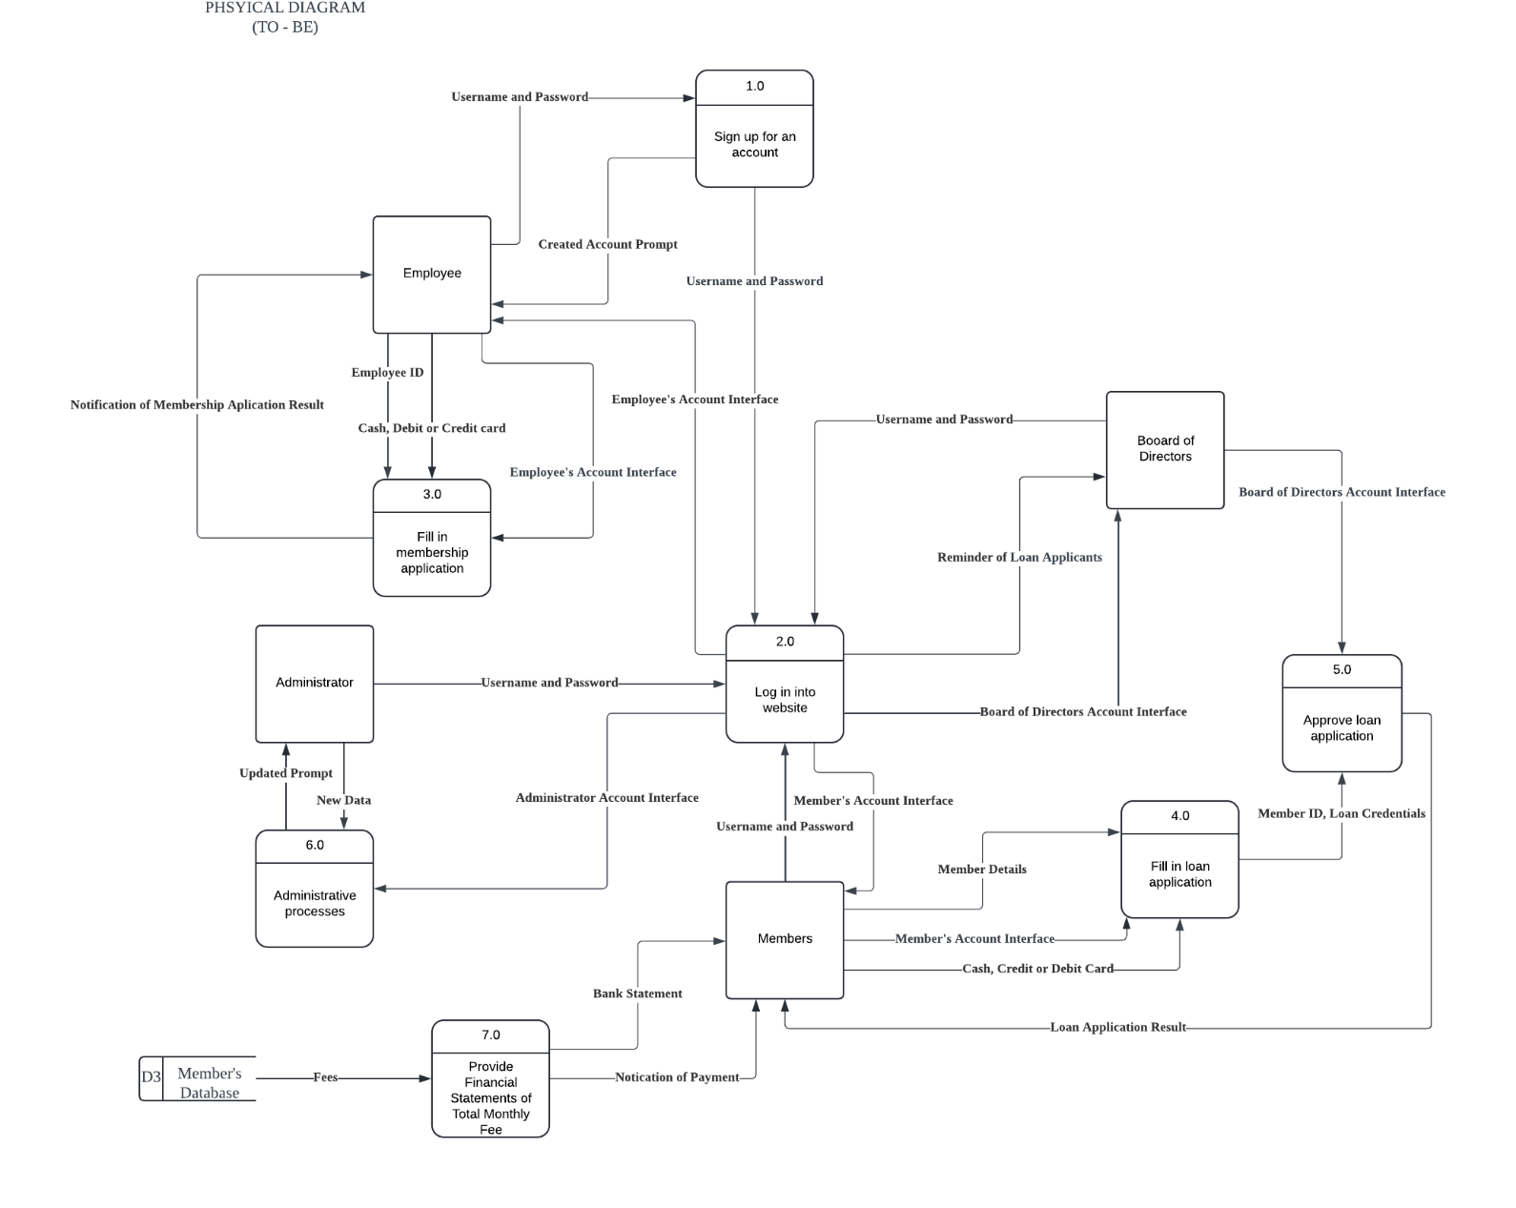
Partitioning
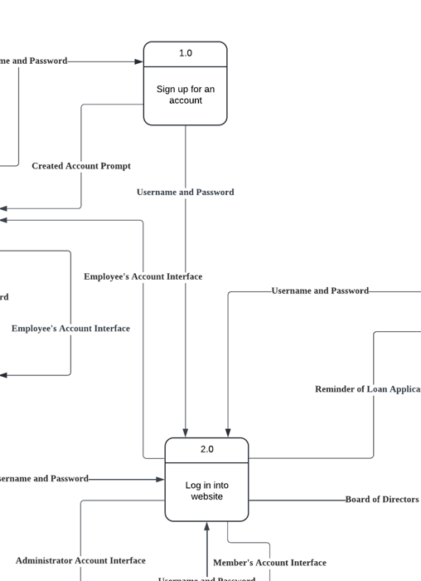
1) Indicates process 1 and process 2 are partitioning together because it performs dependent to each other.

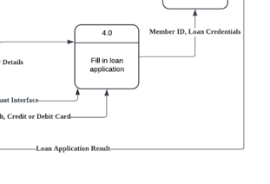
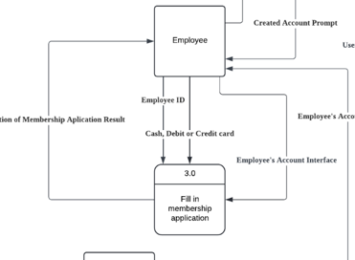

2) Indicates process 3 and process 4 are the almost same task which is Fill the Applications but with the different user groups (employee and member).

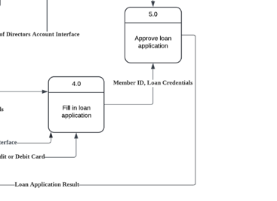
3) Indicates process 4 and process 5 can be partitioning together because it dependent to each other.

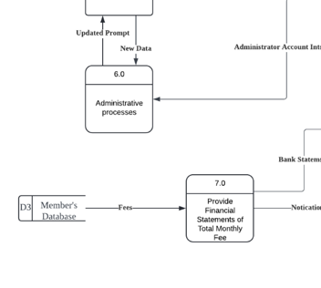
4) Process number 6 and 7 are both a different process but must be a partitional because they are related to each other. Process 6 use to update the data store while process 7 will read the date store.

